**CAPSTONE PROJECT**

**UNIVERSITY SUCCESS RANKING ANALYSIS**



* **RAKESH BABU ARETI**

**INDEX PAGE**

|  |  |
| --- | --- |
| **CONTENTS** | **PAGE NUMBER** |
| Over View | 1 |
| The Process | 2-3 |
| Objectives | 4-5 |
| Significance | 6 |
| Data Dictionary | 7-9 |
| ER Diagram | 10 |
| Power BI Problem Statements | 11-34 |
| EDA Problem Statements | 35-60 |

**OVER VIEW**

The capstone project, titled University Success Analysis: A Comprehensive Exploration of Ranking Systems,' delves into an in-depth examination of university rankings across multiple systems. The main goals encompass the comparison of university rankings, assessing the impact of ranking criteria on university positions, and scrutinizing the dynamic shifts in university metrics over time.

To achieve these objectives, a robust methodology is employed, leveraging the proficiency of SQL and Excel for efficient data aggregation and exploratory data analysis (EDA). Furthermore, a meticulously crafted Power BI dashboard will be developed to provide a holistic visualization of university rankings. This visual representation aims to offer a nuanced understanding of the complex relationships between various criteria and their effects on institutional standings

The dataset encompasses a rich repository of information regarding universities from various countries, meticulously curated across three distinct ranking systems. Additionally, it compiles detailed components about the countries hosting these esteemed universities, including their representation in specific rankings and the criteria utilized for reassessment.

**THE PROCESS**

1. **Data Acquisition from GitHub-**

Retrieve the acoustic dataset from a specified source that contains crucial information about university rankings, encompassing diverse countries and their performance across distinct ranking systems.

1. **Data cleaning and Transformation-**

This stage involves addressing missing values, implementing data normalization procedures, and effectively managing outliers within the dataset. Additionally, considerations for handling missing values include imputation techniques or exclusion based on the extent of missing data. Normalizing the data aims to bring consistency to the scale of variables, ensuring fair comparisons. Outlier management involves identifying and appropriately addressing data points that deviate significantly from the overall pattern, ensuring their impact on analysis is minimized. It's essential to choose normalization and outlier handling methods based on the characteristics of the data and the goals of the analysis.

1. **Connecting with tools**

Integrating the Datasets with Tools and establishing connections with the tools and various analytical tools as well. Interfacing the dataset with power BI, MS-Excel and Sequel work bench and facilitating the seamless data integration and processing of the data accurately.

1. **Problem solving Solution in Power BI**

Explore a wide range of problem statements in Power BI by employing diverse charts and visualizations to enhance data representation. Through meticulous data manipulation and analysis, uncover key insights and trends that offer valuable information for informed decision-making. This comprehensive approach aims to leverage the flexibility of Power BI's visualization tools to address various challenges, ensuring a nuanced understanding of complex data scenarios.

1. **Exploratory Data Analysis (EDA)**

Performing EDA using Excel or MYSQL workbench. It completely depends on the analysis of the statement. The main aim is to extract the meaningful information from the analysis and make use of it.

1. **Creation of Visual and Insightful PowerPoint-**

Developing a comprehensive PowerPoint Presentation that evaluates the clear information of the entire problem statement. It includes the data related to question along with the proper process of solving that Particular one, Also conclusions and insights etc..

1. **Detailed Documentation-**

Compile a detailed report that meticulously documents the entire project lifestyle. Include sections on data collection, transformation, problem statements formulation, tools integration, Power BI solutions. EDA insights and Power Point Visualisations.

**OBJECTIVES**

The university success analysis aims to achieve several key objectives. It involves a thorough examination of university rankings across different system, seeking to understand variations and identify consistently high-performing institutions. A critical aspect of this analysis is the evaluation of the influence of ranking criteria on university positions, providing insights into the factors that significantly contribute to success. Additionally, the study involves a dynamic analysis of university metrics over time, allowing for the identification of trends, improvements, and potential areas of concern.

University rankings are a popular way to compare the quality of different Institutions of Higher Education however there are number of problems with these rankings including variations across systems key factors influence ranking historical Trends and the impact of limitation and bias is on ranking the object of this project is to conduct an excessive analysis of the ranking datasheet in order to export patterns Trends and factors influencing University ranking across different ranking system the goal is to provide inside can be used to enhance the quality and competitive

* Performing a comprehension of universities rankings including variations across system key factors influencing ranking historical terms and the impact of limitations and bias is on ranking driving many full conclusions and recommendations for improving ranking methodologist compiling analysis result conclusions and recommendations was stakeholders.

To facilitate these objectives, the methodology includes the aggregation and organization of data from various sources, creating a comprehensive dataset. Exploratory data analysis is employed to uncover patterns, correlations, and outliers in university success metrics. The presentation of complex data is made accessible through the development of a Power BI dashboard, offering a holistic and interactive view of university rankings. The overarching goal is to extract meaningful insights from the data, informing strategic decisions for universities, policymakers, and other stakeholders. The analysis also involves benchmarking universities against each other and against global standards, identifying areas for improvement and excellence. Ultimately, the findings aim to provide a data-driven framework for continuous improvement and support stakeholders in making informed decisions regarding university success.

**SIGNIFICANCE**

The significance of conducting a university success ranking analysis lies in its potential to yield profound insights that can positively impact Higher Education Institutions (HEIs) on a global scale. Understanding the intricate factors influencing university rankings is pivotal for several reasons.

Firstly, such an analysis enables HEIs to gain a comprehensive understanding of the criteria that contribute to their ranking positions. This knowledge empowers institutions to strategically enhance their strengths, address weaknesses, and align their efforts with the evolving expectations of ranking systems.

Secondly, by identifying trends and patterns in the dynamic landscape of university metrics, institutions can adapt and implement targeted improvements. This adaptability is crucial for staying competitive and relevant in the ever-changing global higher education market.

Thirdly, a robust university success ranking analysis offers institutions a means to benchmark themselves against global standards. This benchmarking process not only provides a measure of an institution's performance relative to peers but also highlights areas for potential growth and development.

Moreover, the findings from such analyses have the potential to inform policy decisions, both at the institutional and governmental levels. Policymakers can use these insights to shape and refine strategies that support the growth and excellence of higher education at a national and international level.

In essence, a university success ranking analysis goes beyond numerical standings; it becomes a catalyst for positive change, fostering excellence, global competitiveness, and continuous improvement within higher education institutions.

**DATA DICTIONARY**

**Dataset Description:**

This dataset comprises information on university rankings from different systems, ranking criteria, and university-specific data.

**Table Explanations-**

1. **Country:**

**About table-**

This is a simple list of countries that were in the data set. I don’t think it’s a complete list of all countries, but it’s enough for this data set.

**About Columns**

* ID: The Unique ID of Each Country.
* COUNTRY NAME: The Name of Each Country.

1. **University:**

**About Table-**

A list of universities that were ranked in this system. Each university is related to a country.

**About Columns**

* ID: The Unique ID of Each University
* Country ID: The ID Of Country
* University name: The Name of The University

1. **Ranking System:**

**About table-**

This contains the three different ranking systems used: Times Higher Education World University Ranking, Shanghai Ranking, and Centre for World University Rankings.

**About Columns-**

* ID: The Unique ID For Each Ranking System.
* System Name: The Name of Each Ranking System.

1. **Ranking Criteria:**

**About Table**

This table contains the different criteria used in each ranking system, such as Citations and Quality of Education. It also contains criteria for Total Score for each system.

**About Columns -**

* ID: The Unique ID For Each Ranking Criteria
* ranking system-id: The ID Of Ranking System
* criteria name: The Name of Each Criteria

1. **University Year:**

**About table-**

The university_year table contains values for measurements such as the number of students and the student to staff ratio for each university in several years.

**About Columns-**

* university-id: ID Of the University.
* year: It Contains Year.
* num-students: Total Number of Students in The University.
* student-staff ratio: Student Staff Ratio of Each University.
* pct international students: Total Percentage of International Students in Each Country.
* pct female students: Total Percentage of Female Students in Each Country.

1. **University Ranking Year:**

**About Table-**

This table contains the score for each year for each university and ranking criteria. It’s the largest table in the database.

**About Columns-**

* university-id: ID Of University
* ranking criteria-id: ID Of Ranking Criteria
* year: It Contains Year
* score: Score of Each University

The data dictionary offers a concise summary of the dataset's architecture, outlining the significance of each field across various tables. The dataset's richness becomes evident as it adeptly captures multifaceted details concerning universities, ranking systems, and evaluation criteria. This comprehensive approach empowers analysts to conduct an in-depth examination of university success, unravelling performance trends and patterns over time.

**ER diagram**

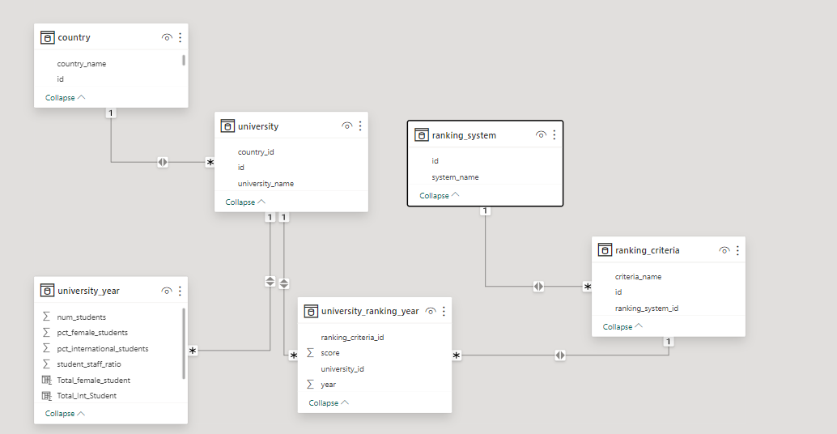

**ER Diagram (Changed as per the Requirement)**

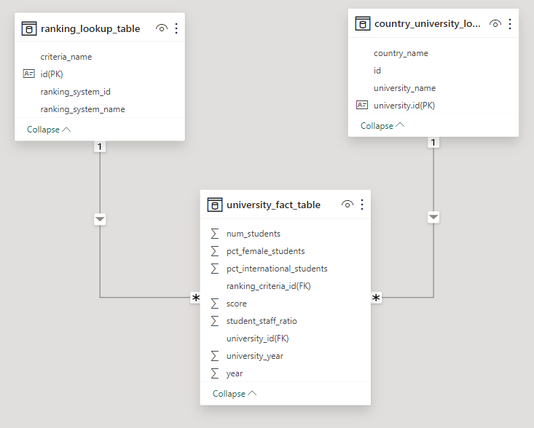

**POWERBI PROBLEM STATEMENTS**

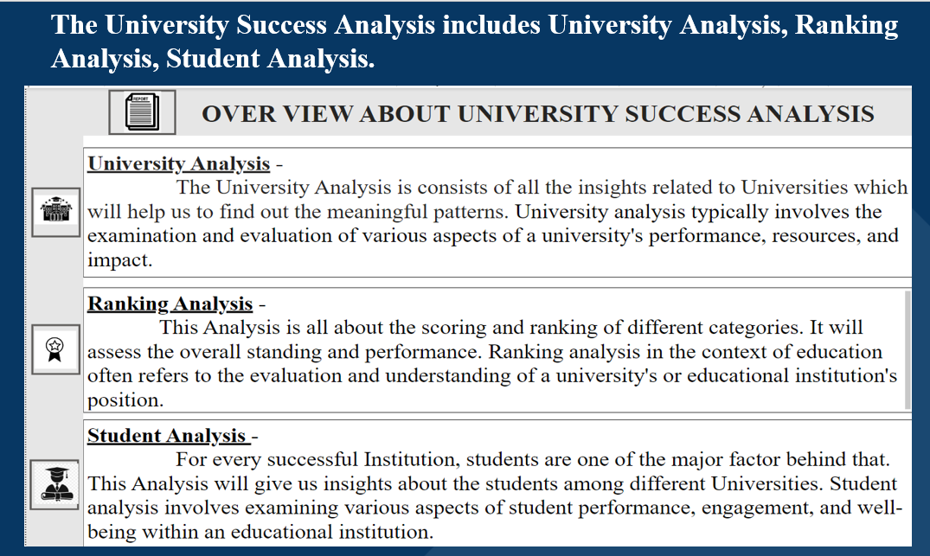

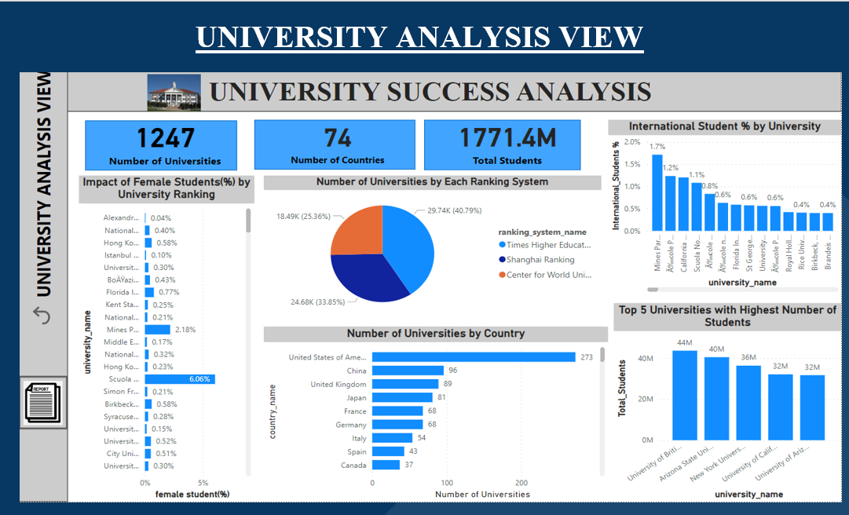

**PROBLEM STATEMENT-**

How does the percentage of female students impact a university's ranking? (Q-8)

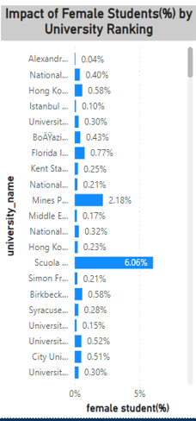

**EXPLANATION-**

The University Ranking is determined by calculating the average score for each university, where the female percentage emerges as a significant factor influencing the ranking. Upon sorting the average scores in Descending Order, a discernible pattern emerges, indicating that the Female Percentage has a moderate yet noteworthy impact on the University's Ranking. This observation underscores the relevance of gender diversity in universities and its correlation with overall institutional success in ranking assessments.

**PROBLEM STATEMENT-**

How many universities are ranked by each ranking system? (Q-3b)

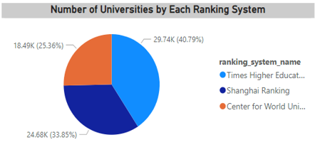

**EXPLANATION-**

The depicted pie chart illustrates the distribution of universities based on different ranking systems. Notably, the majority share is claimed by the "Times Higher Education World University Ranking," representing 40.79% or 29.74 thousand universities. Following closely is the "Shanghai Ranking" with a share of 33.58%, equivalent to 24.68 thousand universities. Subsequently, the "Centre for World University Ranking" holds a portion of 25.63%, accounting for 18.49 thousand universities. This breakdown offers a comprehensive visual representation of the prevalence of each ranking system within the dataset, emphasizing the dominance and distribution trends across these prominent evaluative frameworks.

**PROBLEM STATEMENT-**

How does the percentage of international students vary across different universities? (Q-10)

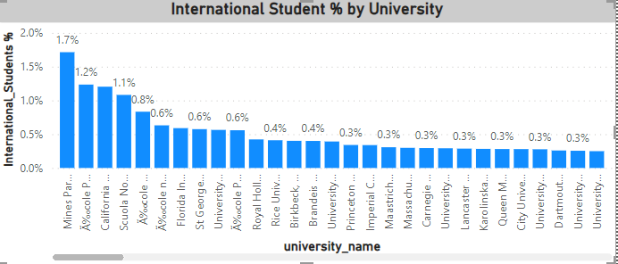

**EXPLANATION-**

The International Student Percentage variable was generated and subsequently utilized in addressing the identified problem statement. Notably, Mines ParisTech emerges with the highest percentage among the universities, showcasing a distinctive position compared to other institutions. It's crucial to acknowledge that each university accommodates a different number of students, leading to variations in the impact of international students on the overall composition. The visual representation effectively captures these differences, offering a nuanced perspective on the diversity in international student enrolment across various universities.

**PROBLEM STATEMENT-**

How many universities are there in each country? (Q-1)

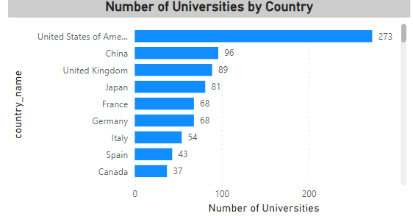

**EXPLANATION-**

The visual presentation provides a comprehensive overview of universities grouped by country. Notably, the United States of America (USA) emerges as the country with the highest number of universities, followed by China with 96 institutions and the United Kingdom (UK) with 89. This trend continues across various nations, showcasing the diverse global distribution of universities. The visual effectively highlights the prominent positions of certain countries in terms of the sheer quantity of universities, offering valuable insights into the worldwide landscape of higher education institutions.

**PROBLEM STATEMENT-**

Which university has the highest number of students? (Q-9)

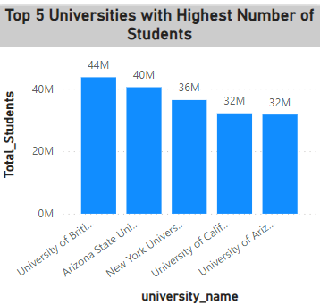

**EXPLANATION-**

The inquiry is centred on identifying the top university with the highest enrollment, and to enhance clarity, the top 5 universities in this regard are being presented. Notably, the University of British Columbia stands out as the institution with the most significant student population. This approach of showcasing the top 5 universities streamlines the presentation, offering a concise view of the institutions that dominate in terms of student enrollment, with the University of British Columbia leading the list.

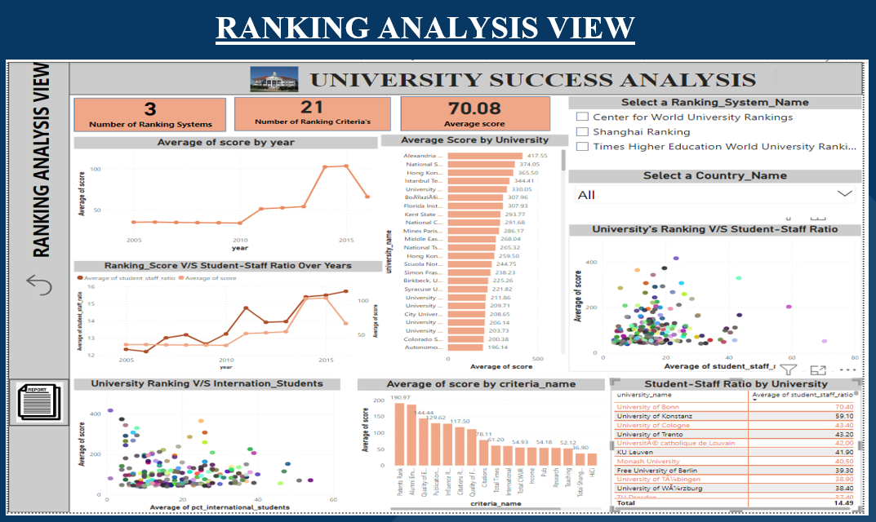

**PROBLEM STATEMENT-**

Are there any significant trends or patterns in the rankings of universities from different countries? (Q-18)

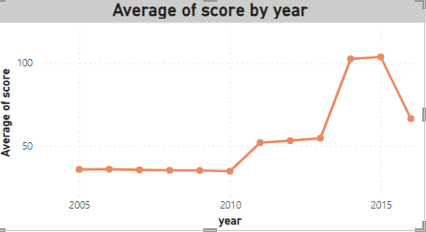

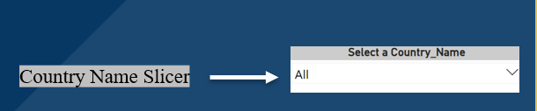

**EXPLANATION-**

The analysis of average scores over the years did not reveal a discernible pattern. To gain a more comprehensive understanding, introducing a slicer for countries could be a valuable approach. This enhanced visualization tool allows for a more targeted exploration of patterns and trends specific to each country, providing a more insightful and nuanced examination of how average scores evolve over time. Utilizing a slicer not only enhances the granularity of the analysis but also enables a more focused and meaningful interpretation of the data, contributing to a more thorough exploration of the factors influencing average scores across different countries.

**PROBLEM STATEMENT-**

Is there a correlation between a university's ranking score and the student-staff ratio over the years? (Q-13)

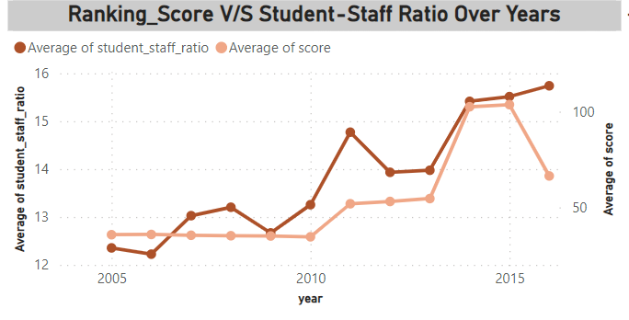

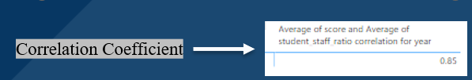

**EXPLANATION-**

A positive correlation has been observed between the Ranking Score (average score) and the Student-Staff Ratio over the years. This indicates a consistent trend: as the Student-Staff Ratio increases on a year-by-year basis, there is a corresponding increase in the average score, and vice versa. This finding underscores the dynamic relationship between these two variables, suggesting that fluctuations in the Student-Staff Ratio play a role in influencing the overall university ranking scores. The understanding of this correlation provides valuable insights into the interplay between student-staff ratios and the perceived performance of universities, contributing to a nuanced understanding of the factors impacting ranking scores over time.

**PROBLEM STATEMENT-**

What is the impact of university's ranking on the number of international students it attracts? (Q-15)

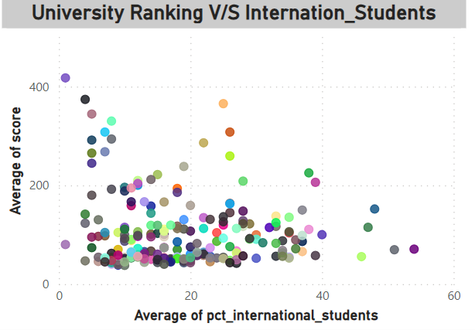

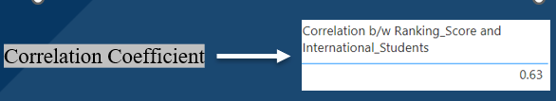

**EXPLANATION**-

A positive impact has been identified between a university's ranking and its ability to attract international students. The observation indicates that as a university's ranking increases, there is a corresponding rise in the number of international students it attracts, and conversely, a decrease in ranking is associated with a decline in international student enrollment. This positive correlation underscores the influence of a university's global standing on its attractiveness to international students. The trend suggests that institutions with higher rankings are more likely to draw a larger international student population, emphasizing the symbiotic relationship between global reputation and international student recruitment.

**PROBLEM STATEMENT-**

What is the average score for universities according to each ranking system? (Q-15)

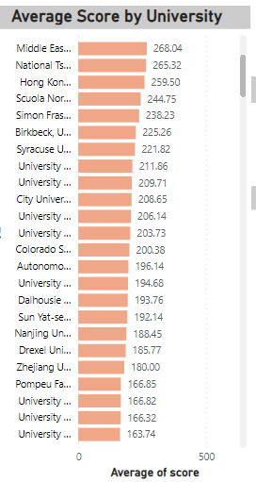

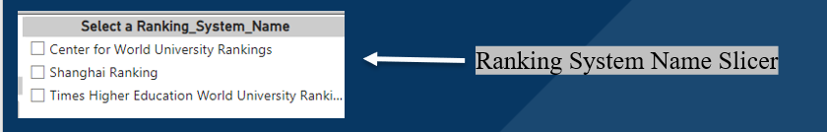

**EXPLANATION-**

The visualization currently displays the average score for each university, providing a broad overview. To delve deeper into the nuanced performance of each university based on different ranking systems, a more detailed analysis can be achieved by incorporating a slicer in Power BI. By introducing a slicer for the ranking system name, users can dynamically filter and analyse the average scores according to their specific requirements. This interactive approach enhances the granularity of the analysis, allowing for a focused examination of how universities fare across distinct ranking systems. The slicer functionality in Power BI thus facilitates a more tailored exploration, catering to the diverse needs and interests of users seeking specific insights related to individual ranking systems.

**PROBLEM STATEMENT-**

What are the most important criteria considered by ranking systems? (Q-6)

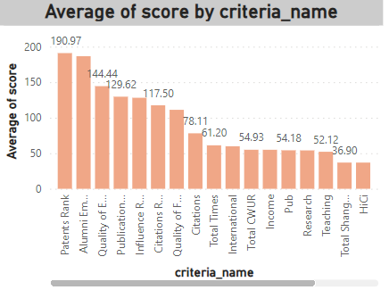

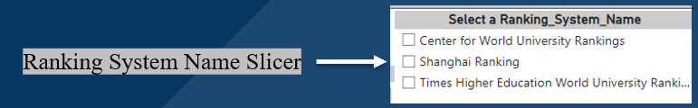

**EXPLANATION-**

In the evaluation of university rankings, the consideration involves calculating the average score for each criteria name. To gain a deeper understanding of the significance of specific criteria within each ranking system, the utilization of a slicer proves valuable. This interactive tool allows users to dynamically explore and analyze the importance of various criteria by selecting their criteria of interest.

However, when looking at the overall ranking, it becomes evident that the 'Patents Rank' emerges as the most crucial criterion. This means that, in the broader context of determining the overall university ranking, the 'Patents Rank' plays a pivotal role. Its prominence underscores the significance of research and innovation, as reflected in patent-related activities, in influencing the comprehensive standing of universities across various ranking systems.

**PROBLEM STATEMENT-**

Is there a correlation between a university's ranking and its student-staff ratio? (Q-15)

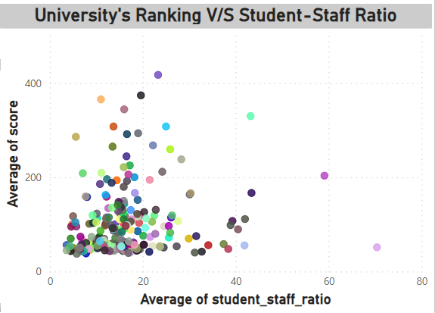

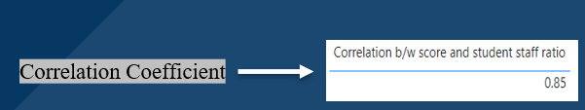

**EXPLANATION-**

A positive correlation has been identified between a university's ranking (average of score) and its student-staff ratio. This implies that as the university's ranking increases, there is a corresponding increase in the student-staff ratio, and conversely, a decrease in ranking is associated with a decline in the student-staff ratio. This positive relationship suggests a dynamic interplay wherein universities with higher rankings tend to exhibit higher student-staff ratios, indicating potentially larger student populations or variations in staffing levels. The correlation emphasizes the influence of ranking on the student-staff dynamic and provides insights into the evolving structure of universities concerning these key metrics.

**PROBLEM STATEMENT-**

How does the ranking system affect a university's student-staff ratio? (Q-5)

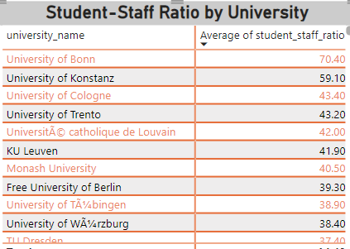

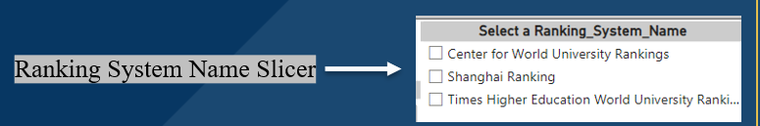

**EXPLANATION-**

The matrix visually presents the average student-staff ratio for each university. To delve into the nuanced impact of different ranking systems on this metric, a more insightful analysis can be conducted using a slicer in Power BI. By incorporating a slicer for ranking systems, users gain the ability to dynamically filter and explore the matrix data based on specific ranking criteria. This interactive approach in Power BI enhances the interpretability of the matrix, allowing for a targeted examination of how various ranking systems influence the student-staff ratio. The utilization of a slicer facilitates a more granular exploration, enabling users to derive meaningful insights and uncover patterns specific to each ranking system's impact on the university's student-staff dynamics.

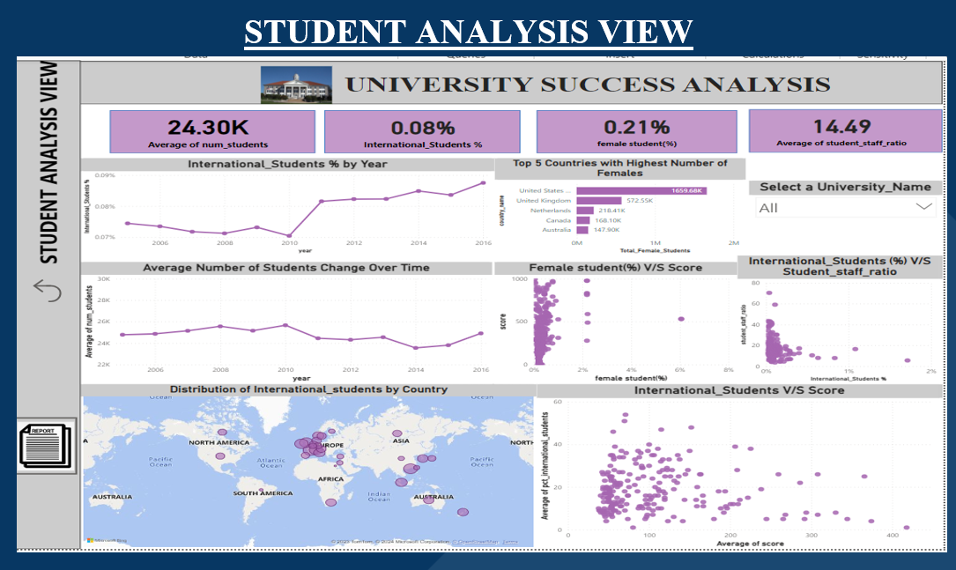

**PROBLEM STATEMENT-**

How does the percentage of international students vary across different years? (Q-14)

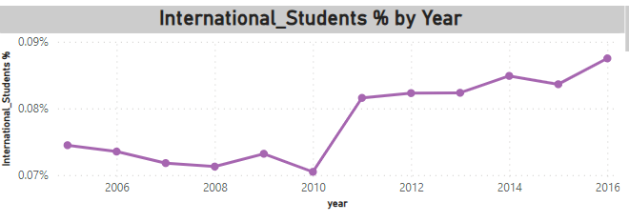

**EXPLANATION-**

The line chart effectively illustrates the fluctuation in the percentage of international students over the years. Initially, there are marginal variations from year to year, indicating a relatively stable trend. However, a notable surge in the percentage of international students becomes apparent from 2011 onwards. Subsequently, the trend continues to evolve, displaying intermittent changes with slight differences in percentage values from year to year.

This observation highlights a pivotal turning point in 2011, suggesting a significant increase in the enrolment of international students across the represented universities. The subsequent years show a more dynamic pattern with modest fluctuations, indicating ongoing changes in the composition of international student populations. The line chart thus provides a clear visual representation of the evolving landscape of international student enrolment over the years, with a distinct shift in trends starting from 2011.

**PROBLEM STATEMENT-**

How does the number of students in universities change over time? (Q-12)

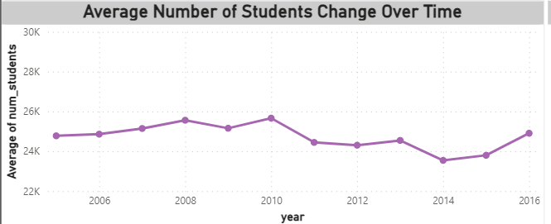

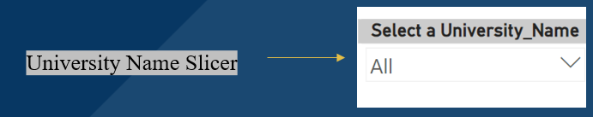

**EXPLANATION-**

The depicted visual effectively portrays the evolution of the average number of students over time, resembling a wave-like structure. To gain a more detailed understanding of how individual universities contribute to this pattern, the introduction of a university name slicer in the analysis can be highly beneficial. By employing this slicer, users can dynamically select and focus on specific universities, obtaining a nuanced view of the change in the number of students over time for each institution. This interactive approach enhances the interpretability of the data, allowing for a more tailored exploration and insightful examination of how each university contributes to the overall wave-like trends observed in the average number of students over time.

**PROBLEM STATEMENT-**

What is the distribution of international students across different countries? (Q-2)

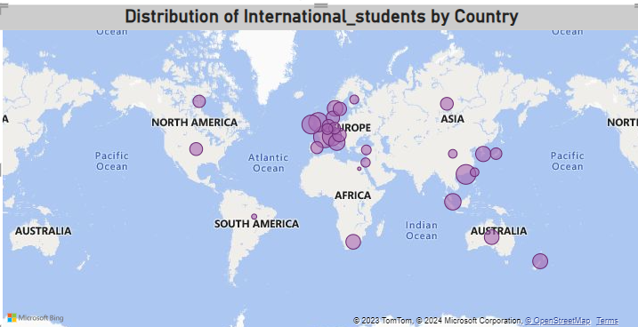

**EXPLANATION-**

The map visualization with bubble sizes effectively illustrates the distribution of international students across different countries. By placing the cursor over each bubble in Power BI, users can glean valuable insights into the specific percentage distribution of international students within each country. This interactive feature enhances the clarity of the visualization, allowing for a dynamic exploration of the concentration and dispersion of international students on a global scale. The use of bubble sizes provides a visual representation of the varying proportions of international students in different countries, making it a powerful tool for comprehending the geographical distribution of this student demographic.

**PROBLEM STATEMENT-**

Which country has the highest number of female students enrolled in universities? (Q-3)

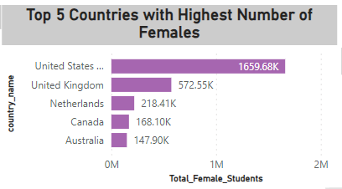

**EXPLANATION**-

The primary query revolves around identifying the country with the highest number of female students. To enhance the visual impact, a strategic decision was made to focus on the top 5 countries with the highest female student enrolment. Consequently, the visualization culminates in highlighting the United States of America (USA) as the country boasting the most substantial female student population when compared to other nations. This approach not only elevates the visual appeal by presenting a concise and impactful representation but also underscores the significant role of the USA in terms of female student enrolment on a global scale.

**PROBLEM STATEMENT-**

Is there a relationship between a university's ranking score and the percentage of female students enrolled? (Q-16)

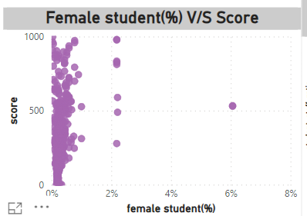

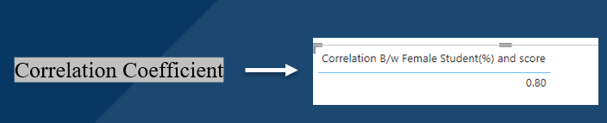

**EXPLANATION-**

A positive correlation has been observed between a university's score and the percentage of female students. This indicates that as the university's score increases, there is a corresponding likelihood of an increase in the female student percentage, and conversely, a decrease in the score might be associated with a decrease in the female student percentage. This positive relationship suggests a dynamic interplay where universities with higher scores tend to exhibit a higher proportion of female students, and vice versa. This correlation underscores the potential influence of overall university performance on gender diversity within student populations, providing insights into the interconnection between academic standing and the composition of female students.

**PROBLEM STATEMENT-**

Is there a relationship between a university's ranking score and the percentage of female students enrolled?(Q-17)

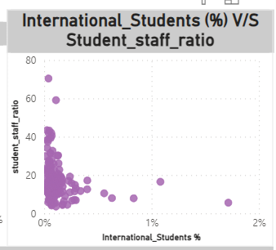

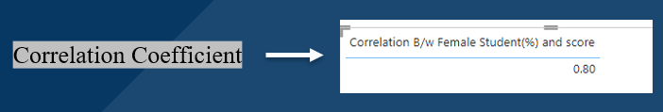

**EXPLANATION-**

A positive correlation has been identified between the percentage of international students and the student-staff ratio. This implies that as the student-staff ratio increases, there is a corresponding likelihood of an increase in the percentage of international students, and conversely, a decrease in the student-staff ratio might be associated with a decrease in the percentage of international students. This positive relationship suggests a dynamic interplay where universities with a higher student-staff ratio tend to attract a higher proportion of international students, and vice versa. The correlation underscores the potential influence of the student-staff dynamic on the internationalization of student populations, providing insights into how staffing levels may impact the diversity of a university's student body

**PROBLEM STATEMENT-**

Is there a correlation between a university's score and the number of international students? (Q-7)

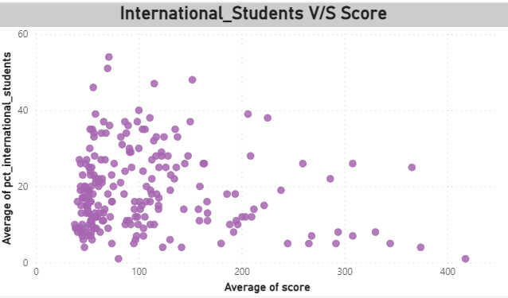

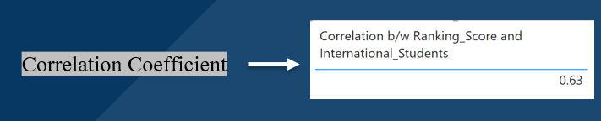

**EXPLANATION-**

A positive correlation has been observed between the number of international students and a university's score. This suggests that as the university's score increases, there is a corresponding likelihood of an increase in the number of international students, and conversely, a decrease in the university's score might be associated with a decrease in the number of international students. This positive relationship indicates a dynamic interplay wherein universities with higher scores tend to attract a larger proportion of international students, and vice versa. The correlation underscores the potential influence of a university's academic standing on its global appeal and ability to attract students from diverse international backgrounds, providing insights into the intersection of academic reputation and international student enrolment.

EDA

(Exploratory Data Analysis)

PROBLEM STATEMENTS

**PROBLEM STATEMENT –**

Is there a correlation between a country's GDP and the number of universities? (Q-1)

**SQL QUERY-**

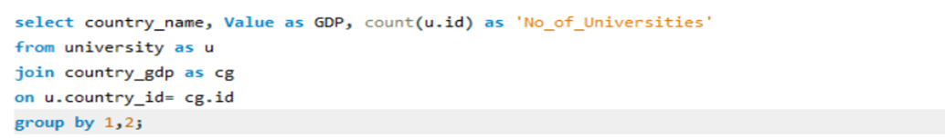

**VISUAL REPRESENTATION-**

**Correlation Coefficient in Excel-**

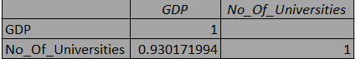

**EXPLANATION-**

The observed correlation coefficient between a country's GDP and the number of universities is 0.94 (0.930171994), indicating a strong positive correlation. This implies that as a country's Gross Domestic Product (GDP) increases, there is a significant likelihood that the number of universities within that country will also increase. Conversely, if the country's GDP experiences a decrease, it is likely that there will be a decrease in the number of universities. This positive correlation underscores the close relationship between a nation's economic strength, as reflected in its GDP, and the prevalence of higher education institutions. The findings suggest that economic prosperity contributes to the establishment and growth of universities within a country.

**PROBLEM STATEMENT-**

How has the number of universities changed over the years in each country? (Q-2)

**SQL QUERY-**

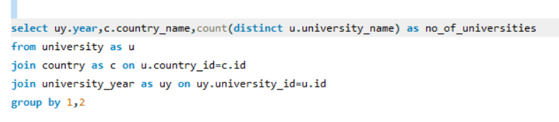

**VISUAL REPRESENTATION**

**Pivot table in Excel-**

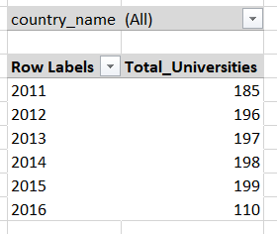 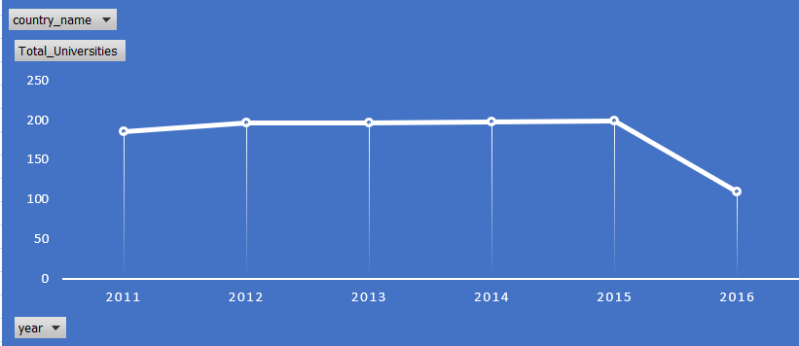

**EXPLANATION-**

The dataset reflects the dynamic evolution of the number of universities over the years for each country. To gain a detailed understanding of how this change has transpired for specific countries, the utilization of the filter option proves instrumental. By leveraging the filter functionality, users can selectively choose and focus on specific countries of interest, enabling a targeted and in-depth analysis of the variations in the number of universities over time. This approach enhances the interpretability of the dataset, allowing for a tailored exploration and meaningful insights into the specific trends and patterns associated with each selected country's higher education landscape.

**PROBLEM STATEMENT –**

Is there a relationship between a country's population and the number of universities? (Q-3)

**SQL QUERY-**

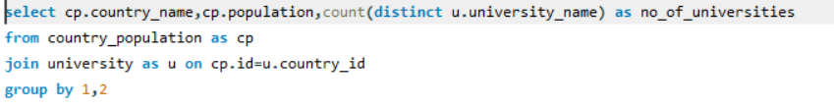

**VISUAL REPRESENTATION-**

**Correlation Coefficient in Excel-**

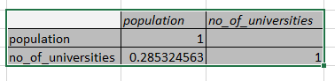

**EXPLANATION-**

The observed correlation coefficient between a country's population and the number of universities is 0.28 (0.285324563), indicating a positive correlation. This implies that there is a tendency for an increase in the population of a country to be associated with a corresponding increase in the number of universities within that country. However, it's noteworthy that while the overall trend is positive, there are some scattered data points that deviate from this general pattern. These outliers may represent instances where the population of a country significantly differs from the average, contributing to a longer spread in the scatter plot.

The positive correlation underscores the idea that as a country's population grows, there is an inclination for the establishment and growth of universities. However, the presence of scattered points suggests that certain countries may exhibit unique characteristics, possibly influenced by factors beyond population size, contributing to variations in the number of universities. This nuanced understanding emphasizes the need for a more in-depth analysis to uncover the specific factors influencing the establishment of universities in individual countries.

**PROBLEM STATEMENT-**

Are there any common criteria used by different ranking systems? (Q-4)

**SQL QUERY-**

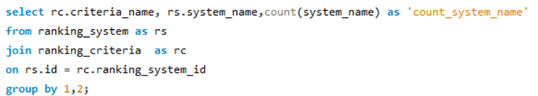

**VISUAL REPRESENTATION-**

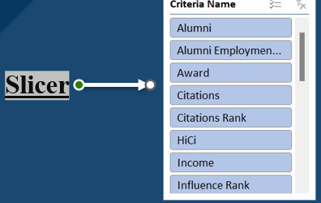

**EXPLANATION-**

The absence of a common set of criteria shared among different ranking systems is evident, indicating that each ranking system employs its own distinct set of considerations and factors. In essence, these ranking methodologies are not universally standardized; rather, they are shaped by the specific criteria and metrics deemed relevant by each system. This diversity in ranking criteria reflects the varied perspectives and priorities of the organizations or entities responsible for formulating these assessments.

Each ranking system is likely to prioritize certain aspects of universities, such as academic reputation, research output, faculty-to-student ratio, or international diversity, according to its unique objectives and values. Consequently, the lack of a standardized set of criteria underscores the dynamic and multifaceted nature of university rankings, where institutions are evaluated through diverse lenses, contributing to a comprehensive but varied landscape of assessments.

**PROBLEM STATEMENT-**

What is the trend in university rankings over the years according to each system? (Q-5)

**SQL QUERY-**

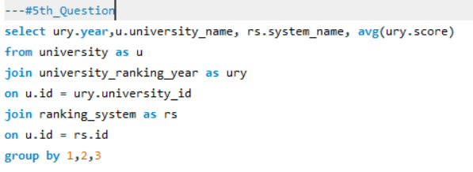

**VISUAL REPRESENTATION-**

**Pivot Table in Excel-**

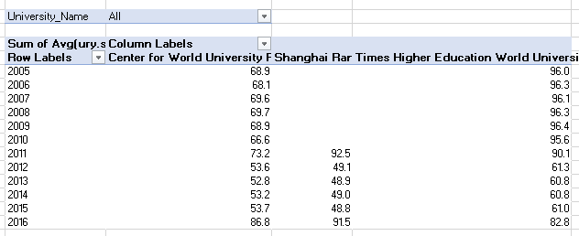

**EXPLANATION-**

The trend in university rankings across three distinct systems reveals an interesting pattern. Despite one ranking system commencing in 2011 while the others have a longer history, a common trend is observed. Initially, universities began with a robust average ranking, experienced a gradual decline in 2012, followed by a period of stability from 2012 to 2015. Subsequently, there was a noticeable upswing in rankings across all three systems.

This shared trajectory implies a synchronized evolution in the perceived performance of universities, transcending the differences in when the ranking systems were initiated. The commonality in the trend suggests that universities, as assessed by these diverse ranking systems, collectively experienced a dip in the early years, followed by a period of stability, and eventually demonstrated an upward trajectory. This shared pattern underscores the coherence in the evaluation of universities, despite variations in the inception years of the ranking systems.

**PROBLEM STATEMENT-**

How does the choice of ranking system affect a university's international student enrolment? (Q-6)

**SQL QUERY-**

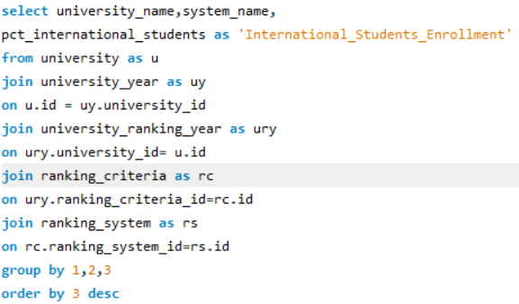

**VISUAL REPRESENTATION-**

**Pivot Table in Excel-**

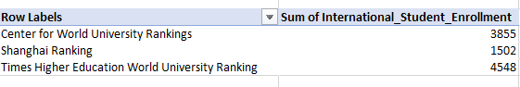

**EXPLANATION-**

The selection of a specific ranking system notably influences the enrolment of international students in universities. In particular, the Times Higher Education World University Rankings have exhibited a discernible impact on the enrolment patterns across various institutions that are part of this particular ranking system. Moreover, the influence extends beyond this system, indicating that other ranking methodologies also play a significant role in shaping the international student enrolment landscape.

This observation underscores the broader impact of ranking systems on the decisions made by prospective international students when choosing universities. The findings emphasize that the reputation and standing of universities, as reflected in various ranking systems, hold substantial weight in influencing the global mobility of students. The implications are far-reaching, showcasing that the choice of a specific ranking system contributes significantly to the internationalization of student populations within higher education institutions.

**PROBLEM STATEMENT-**

Are there any criteria that have different weights in different ranking systems? (Q-7)

**SQL QUERY-**

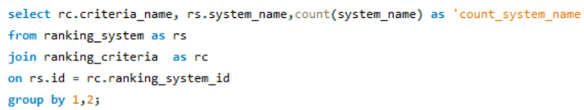

**VISUAL REPRESENTATION-**



**EXPLANATION-**

In the evaluation of universities, each ranking system employs a unique set of criteria, indicating a lack of commonality in the factors considered. Essentially, these systems do not share a standardized set of criteria; instead, they utilize distinct parameters for assessing and ranking institutions. The absence of a common count of criteria highlights the diversity in the methodologies employed by different ranking systems.

This diversity allows each ranking system to prioritize and emphasize certain aspects of university performance based on its objectives and values. The varied criteria reflect the specific perspectives and priorities of the organizations or entities responsible for formulating these assessments. Consequently, the absence of a shared set of criteria underscores the dynamic and multifaceted nature of university rankings, where institutions are evaluated through different lenses, contributing to a comprehensive but varied landscape of assessments

**PROBLEM STATEMENT-**

How have the weights of ranking criteria changed over time?(Q-8)

**VISUAL REPRESENTATION-**

**EXPLANATION-**

The evolution of ranking criteria weights over time reveals a discernible pattern. Initially, these weights were established and remained relatively stable for a considerable period. However, a notable shift occurred in the years 2011 to 2015, marked by a substantial increase in the assigned weights to the criteria. This period was characterized by a heightened emphasis on certain factors within the ranking systems.

Interestingly, the trend took a turn in 2016, witnessing a decline in the weights assigned to the criteria. This shift suggests a recalibration or revaluation of the importance attributed to specific criteria in the assessment process. The observed fluctuations highlight the dynamic nature of the criteria weighting process within ranking systems, reflecting a responsive approach to changing perspectives and priorities in evaluating university performance over time.

**PROBLEM STATEMENT-**

Is there a relationship between a university's score and the student-staff ratio? (Q-9)

**SQL QUERY-**

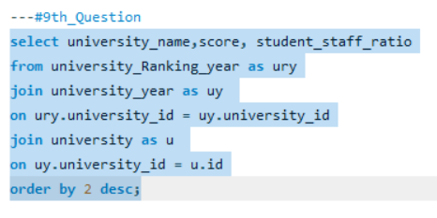

**VISUAL REPRESENTATION (In Power BI)-**

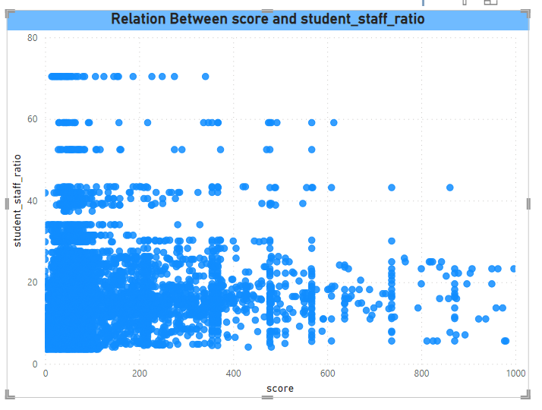

**EXPLANATION-**

A positive correlation is evident between a university's score and its student-staff ratio. This implies that as the student-staff ratio increases, there is a corresponding increase in the university's score, and conversely, a decrease in the student-staff ratio is associated with a decrease in the score. This positive relationship indicates a dynamic interplay wherein universities with higher student-staff ratios tend to achieve higher scores, and vice versa. The correlation underscores the potential influence of the student-staff dynamic on the perceived performance of universities, suggesting that variations in staffing levels may impact the overall scoring within ranking systems.

**PROBLEM STATEMENT-**

How does the number of female students differ among universities? (Q-10)

**SQL QUERY-**

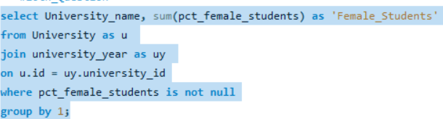

**Pivot table in Excel-**

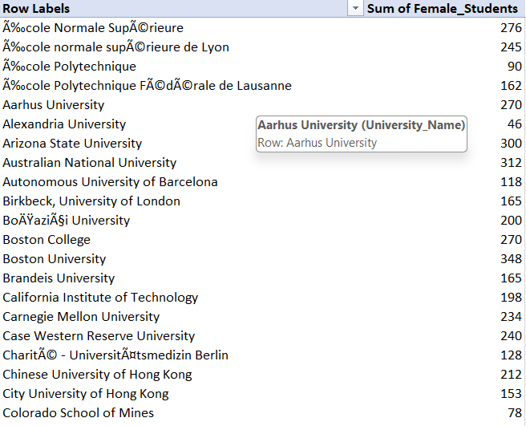

**EXPLANATION-**

The variation in the number of female students across universities is evident in the tabulated data. Given the extensive list of universities, exceeding 200, it becomes challenging to visually represent all the data points in a single visualization due to space constraints. As a result, presenting this comprehensive information in a table format is a practical and effective approach to capture the diversity in the number of female students across the numerous institutions. This tabular representation allows for detailed scrutiny and comparison of the data points without compromising on clarity. While visualizations may have limitations in accommodating a large number of data points, the table format ensures a systematic and accessible exploration of the nuanced differences in the number of female students among the extensive list of universities.

**PROBLEM STATEMENT-**

What is the distribution of universities across different countries?(Q-11)

**SQL QUERY-**

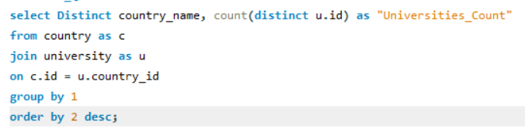

**VISUAL REPRESENTATION-**

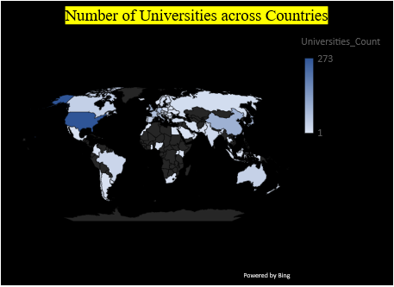

**EXPLANATION-**

The presented map visually communicates the distribution of universities across various countries. The intensity of colour shading serves as an indicator, with darker shades representing countries with the highest number of universities, and lighter shades corresponding to countries with a lower number of universities. This gradation in colour allows for a quick and intuitive assessment of the concentration of higher education institutions in different regions.

The darker hues signify regions with a more prolific presence of universities, while the diminishing colour intensity indicates areas where the density of universities is comparatively lower. This map effectively encapsulates the geographic distribution of universities worldwide, offering a clear and accessible visualization of the disparities in the number of higher education institutions across different countries.

**DISTRIBUTION OF UNIVERSITIES WAY MAP**

**VISUAL REPRESENTATION-**

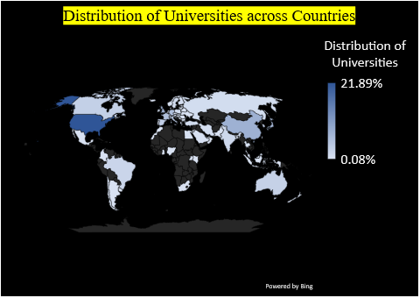

The presented map serves as a visual representation of the distribution of universities across various countries. The varying shades of colour on the map indicate the density of universities in each country. Darker shades represent countries with a higher concentration of universities, while lighter shades suggest a lower density. This map offers an at-a-glance overview, allowing viewers to quickly identify regions where higher education institutions are more prevalent and those where the density is comparatively lower. The colour gradient provides a straightforward way to assess the relative abundance of universities across different countries.

**PROBLEM STATEMENT-**

How has the ranking of universities changed over the years? (Q-12)

**SQL QUERY-**

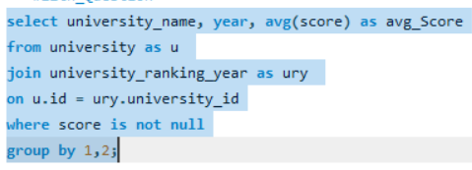

**VISUAL REPRESENTATION-**

**Pivot Table in Excel-**

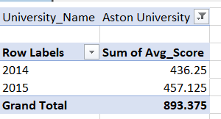

**EXPLANATION-**

The dynamic shifts in the ranking of each university over the years can be effectively examined by implementing a filter for each specific university. Given the extensive list of universities, exceeding 200, individually analyzing each one would be time-consuming. Therefore, a practical approach involves creating a filter that allows for a focused observation of the ranking changes for a particular university over the years.

By implementing this filtering mechanism, users can systematically explore the alterations in the ranking of a chosen university across different years. This method streamlines the analytical process, providing a more manageable and targeted way to comprehend the nuanced fluctuations in university rankings over time.

**PROBLEM STATEMENT-**

What is the trend in the percentage of female students over time?(Q-13)

**SQL QUERY-**

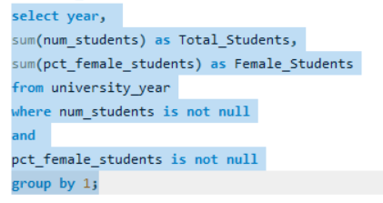

**VISUAL REPRESENTATION-**

**Pivot Table in Excel-**

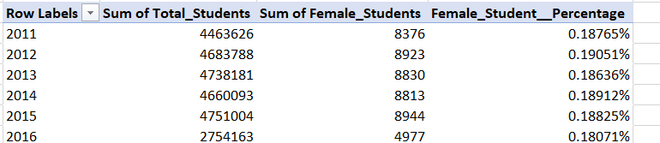 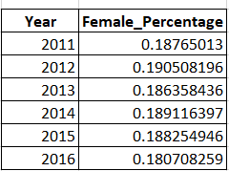

**EXPLANATION-**

The annual female percentage of students appears to exhibit a cyclical pattern resembling a wave. It is noteworthy that there is an increase in one year followed by a subsequent decline, and this pattern repeats over time. Based on this observed trend, an assumption is made that the female percentage of students is likely to rise again in 2017.

This interpretation aligns with the cyclical nature of the data, where historical patterns suggest periodic increases and decreases. While assumptions based on trends can be informative, it's important to approach them with caution, acknowledging that various factors may influence these fluctuations. The anticipation of a rise in female percentage in 2017 reflects an informed speculation derived from the observed cyclical pattern in the dataset.

**PROBLEM STATEMENT-**

How has the ranking score of universities evolved over the years? (Q-14)

**SQL QUERY-**

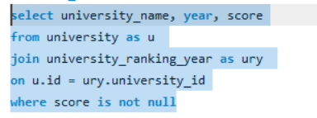

**VISUAL REPRESENTATION-**

**Pivot Table in Excel-**

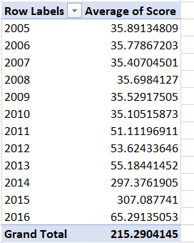

**EXPLANATION-**

In this analysis, the focus is on the average score rather than the cumulative sum of scores. The discerned trend in the scores over the years reveals a distinct pattern. Initially, the scores started at a lower level and remained relatively stable for a period. Subsequently, there was a gradual upward trajectory until 2013, followed by a notable surge in the year 2014. However, two years later, in 2017, there was a decline in the scores.

This nuanced perspective on the average scores provides a clear snapshot of their evolution. The initial stability, gradual increase, sudden spike, and subsequent decline highlight the dynamic nature of the scoring system over the specified timeframe. This refined understanding of the score trend contributes to a more comprehensive analysis of the factors influencing the academic performance of universities over the examined years.

**PROBLEM STATEMENT-**

Is there a relationship between a university's ranking score and the number of students over time? (Q-15)

**SQL QUERY-**

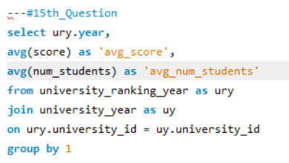

**VISUAL REPRESENTATION-**

**Correlation in Excel-**

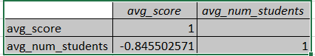

**EXPLANATION-**

In this analysis, the focus is on the average score and average number of students, diverging from the use of total scores and total number of students. The observed correlation between the university ranking score and the number of students over time reveals a significant negative correlation, measured at -0.85 (-0.845502571). This negative correlation indicates that as the university ranking score decreases, there is a corresponding increase in the number of students, and vice versa. The strength of the correlation, denoted by the high negative value, underscores the robustness of this relationship. In practical terms, it suggests that universities with lower ranking scores tend to attract a larger number of students, while those with higher ranking scores experience a comparatively smaller student population. This nuanced insight into the interplay between ranking scores and student enrolment contributes to a more thorough understanding of the dynamics influencing universities over time.